Call for Workshops and Masterclasses
Introduction
We invite proposals for workshops to be held as part of the pre-conference programme during the day before the congress starts. Proposals from all congress themes and subthemes and organisers of all levels of seniority are welcome.
The typical duration for a workshop is one full day (6 to 8 h) half-day workshops can also be accommodated.
Evaluation process
A workshop or masterclass needs to be validated by the International Scientific Committee (ISC) and the national Organising Group (NOC) of the Congress in order to verify that the scientific level of the session’s content is consistent with the level of the other sessions. The validation process is the following:
- Proposals are sent through the congress website according to the established form and deadline.
- Proposals must include a title, brief description and a list of potential speakers.
- Final decision on the selected sessions is taken by ISC and NOC and communicated on time to the convener(s).
Organiser(s) responsibilities
Organiser(s) will be responsible for the design and organization of the workshop or masterclass, which will have an estimated duration of 6 to 8 h in the case of workshops and 1 hour and 30 minutes in the case of masterclasses. They are fully responsible for mobilising everything necessary for the session. The speakers in the workshop must be fully registered at the Congress.
More information
To propose a workshop or masterclass, or to make changes to one already submitted, please contact the COG at abstracts@iahr2025-singapore.com.sg before 30 September 2024.
Key dates
- Workshops / Masterclasses Submission Opens: 1 July 2024
- Workshops / Masterclasses Submission Closes: 30 September 2024
- Notification of Acceptance (Workshops / Masterclasses): 1 December 2024

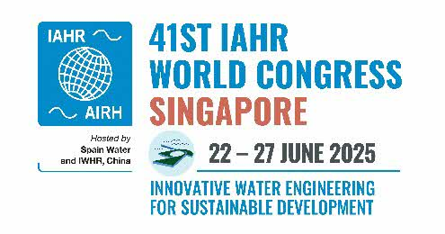
Proposal for a Workshop or Masterclass
Title
Description
Organised by
Alignment with congress theme/s (please select)
Duration (max 6-8 h for workshops and max 90 min for masterclasses)
Speakers (include names, organisation, country)
Contact person (include name and email)

